Verify Broker is installed



Create the CloudEvents Player Service



Create a sink binding



Open CloudEvents Player in Browser

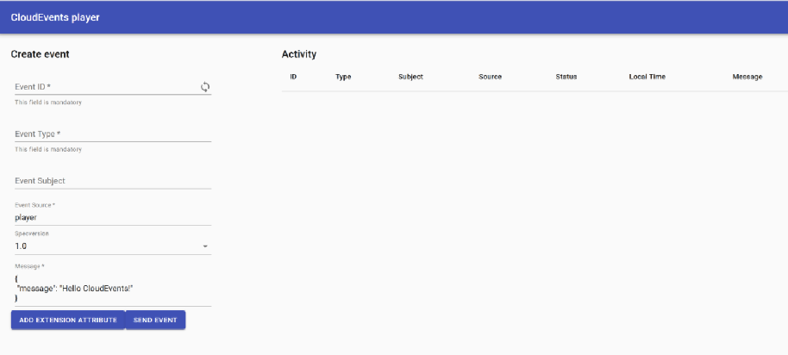

Send Event

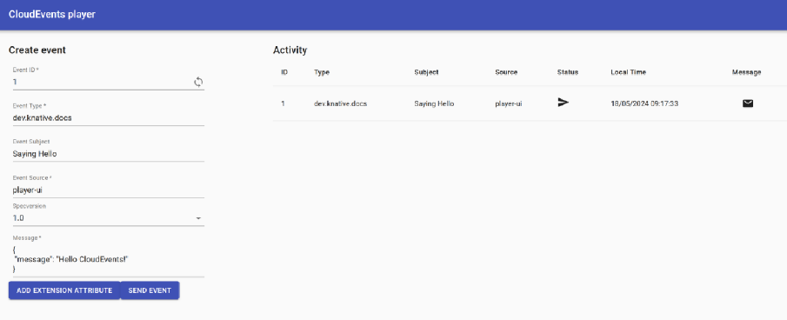

Create Trigger



See events are now sent and received

